Bahria University,

Karachi Campus



LAB EXPERIMENT NO.

**4**

LIST OF TASKS

|  |  |
| --- | --- |
| TASK NO | OBJECTIVE |
| 1 | Display Product Name and its Category Name where Category Name starts with B (Hint: Left join category and product, use wild card) |
| 2 | Display Titles and their quantity (Hint Pubs database, table title and sales, left join) |
| 3 | Use Right join to display Book Title and publisher Names (Hint pubs Database,  Table Title and Publisher) Write down the reason for any null values if coming in title column. |
| 4 | User Right join to display those publishers where title is null. |
| 5 | Use self-join to display Publishers name where country is same (Publisher id should be different) Sample example |
| 6 | Use cross join (Cartesian join) to Display Book Title and Publisher Name. |
| 7 | Use two full joins to Display Product Name, Category Name and Supplier Name (Hint: Below Example) |
| 8 | Use full join to display the name of Supplier for the product starting with letter C (Hint: Northwind) |
| 9 | Get shipper’s Company Name for an order using inner join. (Display only orderID from orders and comapnayName from Customers table) |
| 10 | Count no of Products’s against each suppliers name. list only those products whose count is greater than 3 |
| 11 | Display Region ID, Region Description, Territories Description and (inner join with table Territories and Region) |
| 12 | Display Company Name and Total orders placed by the company (Table: orders, customer, use inner join, group by) |

Submitted On:

Date: 30/03/2022

**Task No. 1:** Display Product Name and its Category Name where Category Name starts with B (Hint: Left join category and product, use wild card)

**Solution:**

select Products.ProductName,Categories.CategoryName from Products left join Categories on Categories.CategoryID = Products.CategoryID where Categories.CategoryName like 'B%'

**Output:**

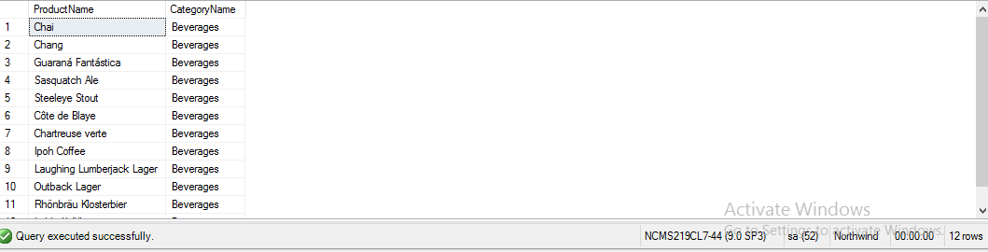

**Task No. 2:** Display Titles and their quantity (Hint Pubs database, table title and sales, left join)

**Solution:**

select titles.title,sum(sales.qty) as qty from titles left join sales on titles.title_id=sales.title_id group by titles.title

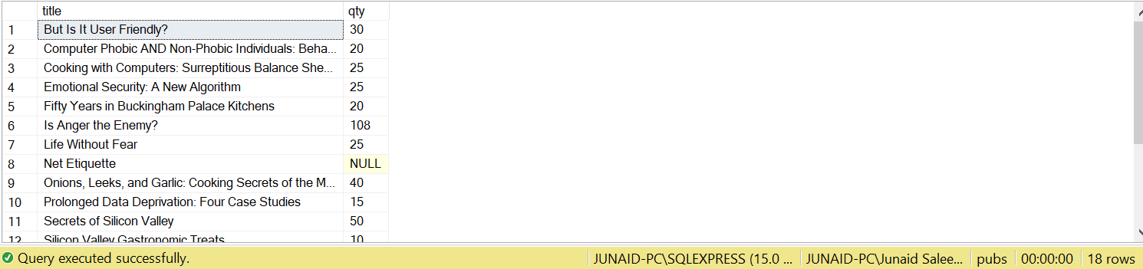

**Output:**

**Task No. 3:** Use Right join to display Book Title and publisher Names (Hint pubs Database, Table Title and Publisher) Write down the reason for any null values if coming in title column.

**Solution:**

select titles.title,publishers.pub_name from titles right join publishers on titles.pub_id=publishers.pub_id

**Reason:** **The result is NULL from the left side (title column), because Right join returns all rows from the right table and matched records from the left table or returns null if it does not find any matching record. If it finds unmatched records from the left side table, it returns Null value.**

**Output:**

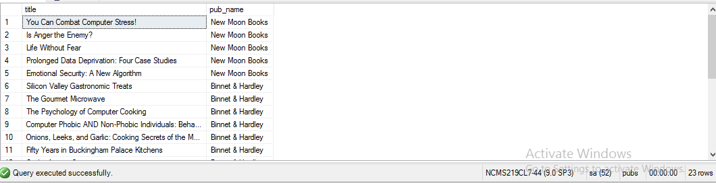

**Task No. 4:** User Right join to display those publishers where title is null.

**Solution:**

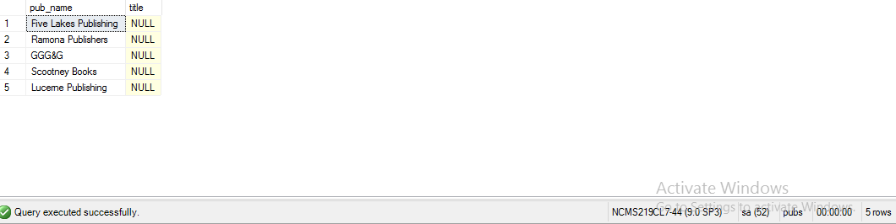SELECT publishers.pub_name, titles.title FROM titles RIGHT JOIN publishers ON publishers.pub_id = titles.pub_id where titles.title is null;

**Output:**



**Task No. 5:** Use self-join to display Publishers name where country is same (Publisher id should be different) Sample example

**Solution:**

SELECT A.pub_name AS PublisherName1, B.pub_name AS PublisherName2, A.country FROM publishers A, publishers B where A.country=B.country and A.pub_id<>B.pub_id

**Output:**

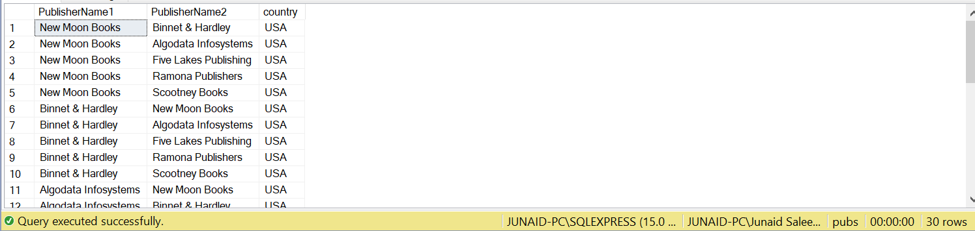

**Task No. 6:** Use cross join (Cartesian join) to Display Book Title and Publisher Name.

**Solution:**

select pub_name,title from publishers cross join titles

**Output:**

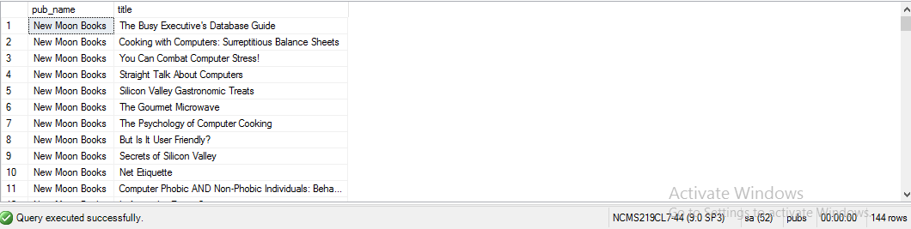

**Task No. 7:** Use two full joins to Display Product Name, Category Name and Supplier Name (Hint: Below Example)

**Solution:**

select Products.ProductName, Categories.CategoryName, Suppliers.ContactName from Products full join Suppliers on Suppliers.SupplierID=Products.SupplierID full join Categories on Products.CategoryID=Categories.CategoryID

**Output:**

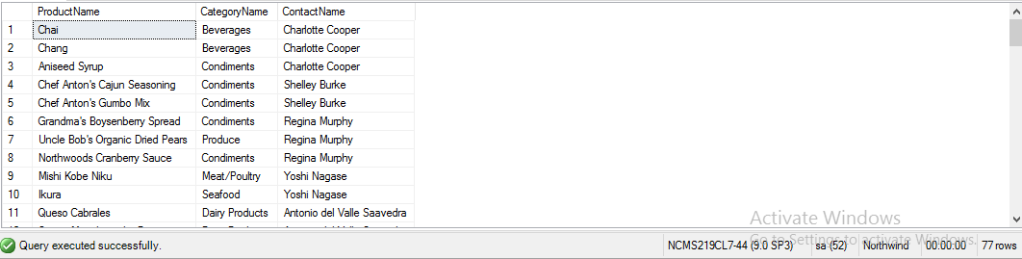

**Task No. 8:** Use full join to display the name of Supplier for the product starting with letter C (Hint: Northwind)

**Solution:**

select products.ProductName,suppliers.ContactName from suppliers full outer join products on suppliers. SupplierID = products.SupplierID where products.ProductName like 'C%'

**Output:**

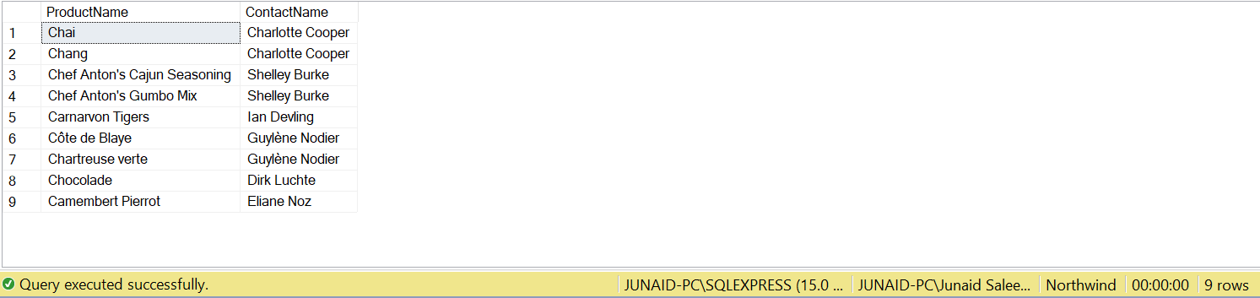

**Task No. 9:** Get shipper’s Company Name for an order using inner join. (Display only orderID from orders and comapnayName from Customers table)

**Solution:**

Select Orders.OrderID, Customers.CompanyName from Orders INNER JOIN Customers ON Orders.CustomerID = Customers.CustomerID ;

**Output:**

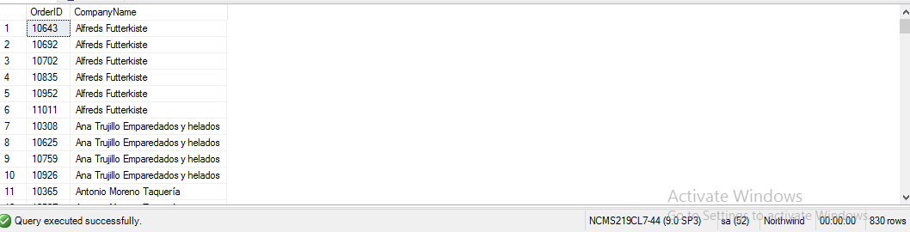

**Task No. 10:** Count no of Products’s against each suppliers name. list only those products whose count is greater than 3.

**Solution:**

Select COUNT(Products.ProductID) AS [NO OF PRODUCTS], Suppliers.ContactName

from Products INNER JOIN Suppliers ON Products.SupplierID = Suppliers.SupplierID GROUP BY(Suppliers.ContactName) having COUNT(Products.ProductID)>3;

**Output:**

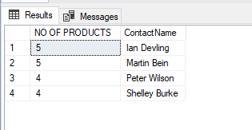

**Task No. 11:** Display Region ID, Region Description, Territories Description and (inner join with table Territories and Region)

**Solution:**

Select Region.RegionID, Region.RegionDescription, Territories.TerritoryDescription

from Region INNER JOIN Territories ON Region.RegionID = Territories.RegionID;

**Output:**

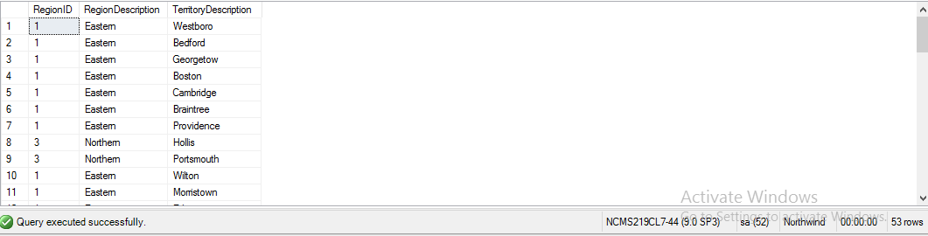

**Task No. 12:** Display Company Name and Total orders placed by the company (Table: orders, customer, use inner join, group by)

**Solution:**

Select COUNT(Orders.OrderID) AS [TOTAL ORDERS], Customers.CompanyName

from Orders INNER JOIN Customers ON Orders.CustomerID= Customers.CustomerID Group by (Customers.CompanyName);

**Output:**

